FOR IMMEDIATE RELEASE

JULY 10, 2019

STRAIGHT NO CHASER TO FILM NEW NATIONAL TELEVISION SPECIAL

RENOWNED A CAPPELLA GROUP RETURNS TO INDIANA TO TAPE “BACK HOME AGAIN”

LIMITED TICKETS AVAILABLE FOR AUGUST 10TH TAPING AT INDIANAPOLIS’S ICONIC MURAT THEATRE

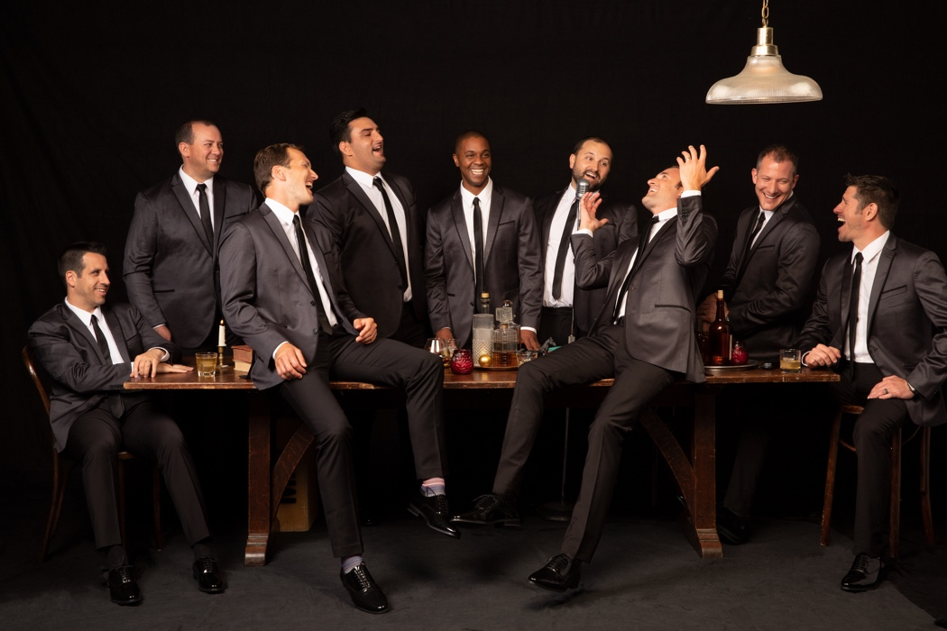

Renowned a cappella group Straight No Chaser, who were at the forefront of the pop culture a cappella movement more than a decade ago with their breakthrough album Holiday Spirits, have announced plans to tape their third national television special, following the success of their prior PBS specials, “Live in New York” and “Songs of the Decades.” “Back Home Again,” scheduled to begin airing nationwide this fall, will find the nine members returning to Indiana, where their story began, to capture a one-night-only performance at the iconic Murat Theatre.

A pre-sale will begin tomorrow morning at 10 AM Eastern, and any remaining tickets will go on-sale to the general public at noon Eastern on Monday, July 15th. For all details, visit Straight No Chaser’s site.

Joe Thomas, executive producer of PBS’s “Soundstage,” will direct the special. Thomas’s credits include video projects featuring Ringo Starr, Robert Plant, Michael McDonald, Phil Collins, Stevie Nicks, Bon Jovi, and Tom Petty and the Heartbreakers.

The taping will provide a sneak preview to the 2019 edition of the group’s annual fall tour. Kicking off October 25 in Biloxi, MS, the two month long trek wraps on New Year’s Eve in Portland, OR. Full dates are listed below.

Straight No Chaser’s latest studio album, “ONE SHOT“ is available now HERE. The album showcases the group’s signature takes on classic pop and soul favorites, including Ricky Martin’s “Livin La Vida Loca,” Fleetwood Mac’s “Go Your Own Way,” James Brown’s “Papa’s Got a Brand New Bag,” and the LP’s first single, an energetic mash-up of Boyz II Men and Montell Jordan’s “Motownphilly/This Is How We Do It.”

Following an unlikely discovery of a nine-year-old video of the group’s version of “The 12 Days of Christmas” by Atlantic Records Chairman/CEO Craig Kallman, Straight No Chaser subsequently became one of the first a cappella groups to sign to a major label and carved the path for the pop culture phenomenon that the genre has become. Since the 2008 release of their first album, Holiday Spirits, the group has sold more than 1.6 million albums in the US alone, with that album and their second holiday album, Christmas Cheers, earning gold certification and reaching the top slot on the holiday charts at Amazon and iTunes.

CONNECT WITH STRAIGHT NO CHASER:
SNCMUSIC.COM
FACEBOOK
INSTAGRAM
TWITTER
YOUTUBE

(TOUR ITINERARY ATTACHED)

STRAIGHT NO CHASER
ON TOUR 2019

AUGUST
7 Portsmouth, NH The Music Hall
8 Portsmouth, NH The Music Hall

SEPTEMBER
10 Copenhagen, Denmark Amager Bio
11 Skive, Denmark KutlurCenter Limfjord
12 Berlin, Germany Columbia Theater
13 Warsaw, Poland Klub Stodola
14 Vienna, Austria SiMM City
16 Paris, France Alhambra
17 Brussels, Belgium La Madeline
20 London, UK Leicester Square Theatre
22 Dublin, Ireland National Concert Hall

OCTOBER
25 Biloxi, MS IP Casino
27 Chattanooga, TN Tivoli Theatre
28 Champaign, IL Virginia Theatre
29 Appleton, WI Fox Cities Performing Arts Center

NOVEMBER
1 Sioux Falls, SD Washington Pavilion
2 Prior Lake, MN Mystic Lake Casino
3 Cedar Rapids, IA Paramount Theatre
4 Madison, WI Overture Center
6 Emporia, KS Emporia Arts Council
7 Conway, AR Reynolds Performance Hall
8 Austin, TX Bass Concert Hall
9 San Antonio, TX Majestic Theatre
10 Dallas, TX McFarlin Auditorium
13 Melbourne, FL Maxwell C. King Center for the Performing Arts
14 Tampa, FL David A. Straz, Jr. Center for the Performing Arts
15 Fort Myers, FL Barbara B Mann Performing Arts Center
16 Fort Lauderdale, FL Broward Center for the Performing Arts
17 Sarasota, FL Van Wezel Performing Arts Center
19 Gainesville, FL Curtis M. Philips Center for the Performing Arts
20 Atlanta, GA Cobb Energy Performing Arts Center
21 Nashville, TN Ryman Auditorium
22 St Louis, MO Fox Theatre
23 Cincinnati, OH Taft Theatre (2 Shows)
24 Hershey, PA Hershey Theatre (2 Shows)
29 New Buffalo, MI Four Winds Casino
30 Mt Pleasant, MI Soaring Eagle Casino

DECEMBER
1 Louisville, KY Kentucky Center for the Performing Arts
3 Evansville, IN Old National Events Plaza
4 Toledo, OH Stranahan Theatre
5 Columbus, OH Palace Theatre
6 Detroit, MI Fox Theatre
7 Indianapolis, IN Murat Theatre (2 Shows)
8 Indianapolis, IN Murat Theatre (2 Shows)
10 Fort Wayne, IN Embassy Theatre
11 Des Moines, IA Civic Center
12 Kansas City, MO Arvest Bank Theatre at the Midland
13 Bloomington, IN IU Auditorium
14 Chicago, IL Chicago Theatre (2 shows)
15 Cleveland, OH KeyBank State Theatre (2 Shows)
17 Buffalo, NY Shea’s Performing Arts Center
18 Pittsburgh, PA Benedum Center for the Performing Arts
19 Baltimore, MD Modell Lyric
20 Uncasville, CT Mohegan Sun Arena
21 Atlantic City, NJ Ocean Casino Resort
22 Easton, PA State Theatre (2 Shows)
23 Everett, MA Encore Boston Harbor
27 Reno, NV Grand Theatre
28 Cerritos, CA Cerritos Center for the Performing Arts
29 San Francisco, CA Davies Symphony Hall
30 Seattle, WA McCaw Hall
31 Portland, OR Keller Auditorium

www.sncmusic.com/tour

# # #

Contact:
Ashley White
Ashley White Public Relations
(512) 436-9260
ashley@ashleywhitepr.com

